

**UR Viswaanand** (Erasmus student)

COURSE: DATABASES

ASSIGNMENT 8

SQL FUNDAMENTALS

JOIN OPERATIONS

SQL SERVER MANAGEMENT STUDIO

2018

**Theory Part:**

JOIN OPERATION:

Sql Join operation is a query that used to combine the tables it can be two or more tables in database, the query data from two or more tables, based on a connection in-between current columns in these tables.

Inner join example

There are related join operations:

Inner Join− it returns row when it both is similar tables.

Left Join− it returns only in left table from the row, even if there is no similar in right table.

Right Join – it returns only in right table form the row, even if there is no similar in left table.

Full Join − returns rows when there is a match in one of the tables.

Self-Join− usually it join itself if there are two tables.

Cartesian Join− this is differ from other join it is only return Cartesian product with the set of records form the two or more joined tables.

Reference:

<https://www.w3schools.com/sql/sql_join.asp>

<https://www.tutorialspoint.com/sql/sql-using-joins.htm>

<https://www.techonthenet.com/sql/joins.php>

**Practical Part:**

1. List some information of all private owners, along with some information of their properties for rent. Include at least columns FirstName and FamilyName from PrivateOwner table and columns Street and TypeOfProperty from PropertyForRent table. Put the list in order of Familyname. Use JOIN or INNER JOIN operation.

|  |
| --- |
| Select FamilyName, FirstName, Pro.Street  AS TargetStreetAddress,TypeOfProperty  From PrivateOwner pri INNER JOIN PropertyForRent pro  ON Pro.PrivateOwnerId=pri.Id  ORDER BY FamilyName; |

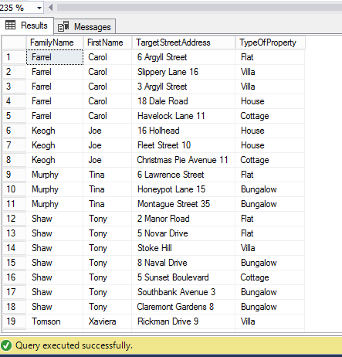

1. Find the number of properties handled by each staff member. Include column FamilyName from Staff table. Use JOIN or INNER JOIN operation. NOTICE! Using JOIN or INNER JOIN means that those properties which are not managed by any staff member will not be included. Neither will those staff members who have nothing to manage be included.

|  |
| --- |
| Select FamilyName,Count(*)AS NumberOfmanagedProperties  From Staff s JOIN PropertyForRent p  ON P.StaffId=s.Id  GROUP BY FamilyName  ORDER BY FamilyName; |

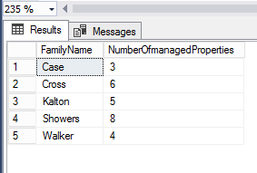

3. Does each staff member have at least one property for rent to manage? Include at least columns FirstName, FamilyName and Position from Staff table and columns Street and TypeOfProperty from PropertyForRent table. Execute LEFT OUTER JOIN or LEFT JOIN with Staff and PropertyForRent tables.

|  |
| --- |
| Select FirstName,FamilyName,Position,  pro.Street AS TargetStreetAddress, TypeOfProperty  From Staff LEFT JOIN PropertyForRent pro  ON staff.Id=pro.StaffId  ORDER BY FamilyName |

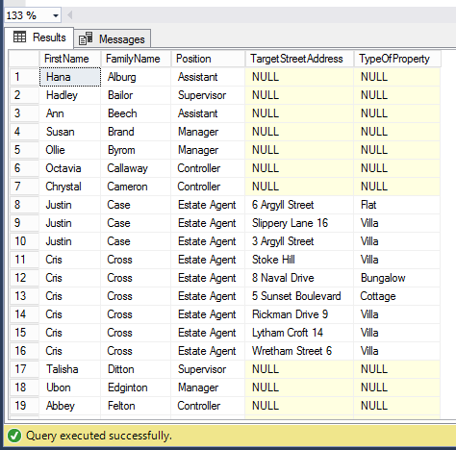

4. Is each property for rent managed by a staff member? Include at least columns FirstName and FamilyName from Staff table and Columns Street and TypeOfProperty from PropertyForRent table. Execute RIGHT OUTER JOIN or RIGHT JOIN with the Staff and PropertyForRent tables.

|  |
| --- |
| SELECT FamilyName, FirstName, Position,  pro.Street AS TargetStreetAddress, TypeOfProperty  FROM Staff RIGHT JOIN PropertyForRent pro  ON Staff.Id=pro.StaffId  ORDER BY FamilyName; |

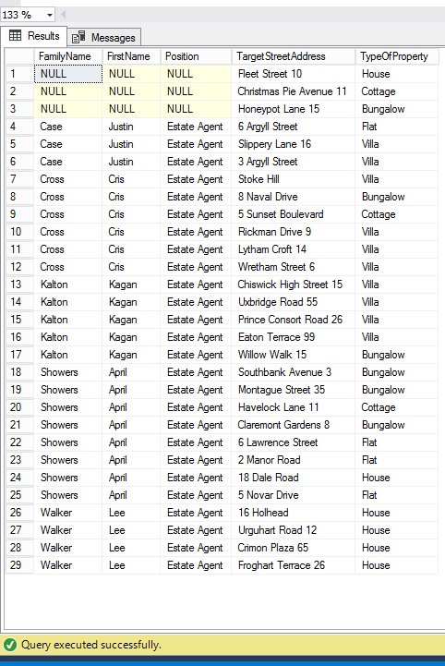

5. List what is available for rent in the company. Choose columns TypeOfProperty and Rent from PropertyForRent table and column Street from Branch table (so you can also see which Branch offers what from the list). Make it so that TypeOfProperty serves as major sort key and Rent as minor sort key.

|  |
| --- |
| SELECT TypeOfProperty, Rent, br.Street AS StreetAddress  FROM Branch br FULL JOIN PropertyForRent pro  ON br.Id=pro.BranchId  ORDER BY TypeOfProperty, Rent DESC; |

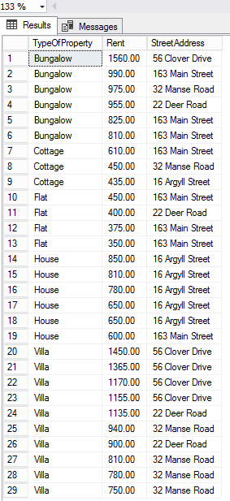

6. List the names of all clients who have viewed a property, along with any comments supplied. Include at least columns FamilyName and FirstName from Client table and column CommentsGiven from Viewing table. Organize the list in alphabetical order of FamilyName.

|  |
| --- |
| SELECT FamilyName, FirstName, ViewDate, CommentsGiven  FROM Client cl FULL JOIN Viewing vi  ON cl.Id=vi.ClientId  ORDER BY FamilyName; |

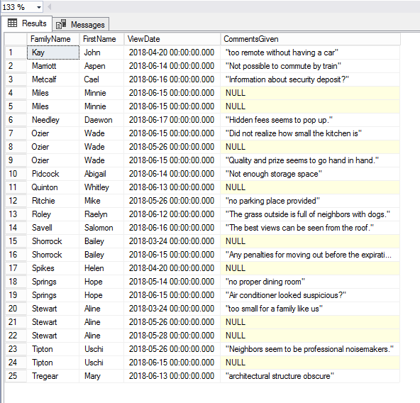

7. Same as previous task but this time exclude those who did not give any comments.

|  |
| --- |
| SELECT FamilyName, FirstName, CommentsGiven  FROM Client cl FULL JOIN Viewing vi  ON cl.Id=vi.ClientId  WHERE CommentsGiven IS NOT NULL  ORDER BY FamilyName; |

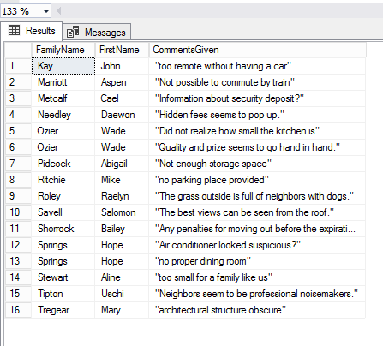

8. List the names of all staff and the street address where they work. Choose at least columns FirstName and Familyname from Staff table and column Street from Branch table. Organize the list in alphabetical order of FamilyName.

|  |
| --- |
| SELECT FamilyName, FirstName, br.Street  FROM Staff st JOIN Branch br  ON st.BranchId=br.Id  ORDER BY FamilyName; |

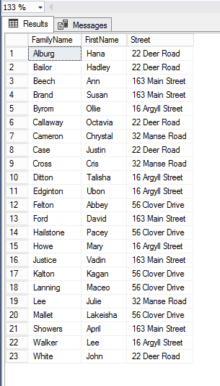

9. Who are the owners for the properties for rent and what do they own? Include at least columns FirstName and Familyname from PrivateOwner table and columns Street and TypeOfProperty from PropertyForRent table.

|  |
| --- |
| SELECT FamilyName, FirstName, pr.Street, TypeOfProperty  FROM PrivateOwner po JOIN PropertyForRent pr  ON po.Id=pr.PrivateOwnerId  ORDER BY FamilyName; |

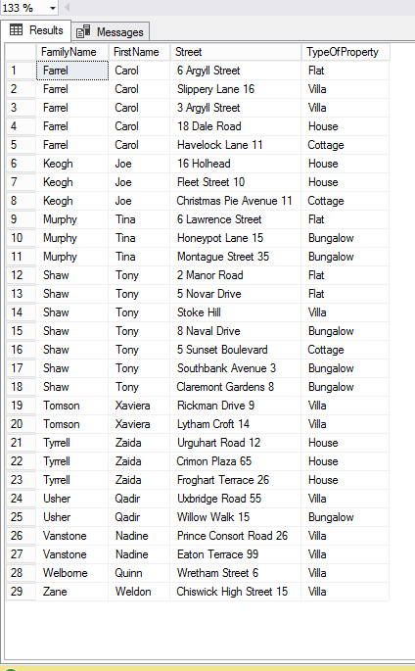

10. Now you need to know what kind of properties each branch offers. Choose at least column Street from Branch table and columns Street, TypeOfProperty, and Rent from PropertyForRent table. Choose column Street from Branch table as your major sort key and column TypeOfProperty as your minor sort key.

|  |
| --- |
| SELECT br.Street AS 'Branch Street', pr.Street, TypeOfProperty, Rent  FROM Branch br JOIN PropertyForRent pr  ON br.Id=pr.BranchId  ORDER BY br.Street, TypeOfProperty; |

